Dear Fourth Grade Parents,
Welcome to the start of the year 2015-2016. The long summer vacation has ended and we have a lot to look forward to in the new academic school year.

I will be teaching all subjects, except Science, to the fourth grade. We will be building on what your children have learned in the third grade last year in Reading, Language Arts, Math, and Social Studies. In Math especially, your child will need to have mastered the multiplication facts by the beginning of fourth grade. Your child should memorize and recite these tables every day to ensure mastery of the 1-10 times tables. They will be tested in the first week to see if they can recite these tables. Only then will we be able to move on to Multiplication and Division which has to be mastered in the fourth grade.

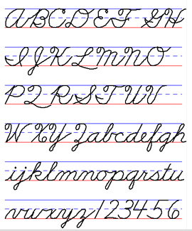
Math homework is given every day. This reinforces what has been taught in class that day. Please see that your child completes this homework.

Fourth grade students are expected to use cursive writing. Please help them practice at home too, so that they can work up speed in cursive writing.

I request you to go over the rules for good behavior with your child before school begins. Learning can then take place at an appropriate pace.

I look forward to working with your child. Please feel free to contact me at any time if you have concerns.

Mrs. Patricia Lobo

