Religion Prayers to Practice
Dear Parents,
These are the prayers that your child must know in 1st Grade. Please practice these prayers often with your child at home. Each student must recite their prayers orally in class and will be tested on all prayers by the end of the year.
Thank you! ~ Mrs. Powell
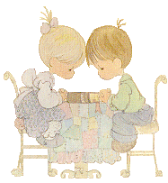
Our Father:
Our Father, who art in heaven, hallowed be thy name; thy kingdom come; thy will be done on earth as it is in heaven. Give us this day our daily bread; and forgive us our trespasses as we forgive those who trespass against us; and lead us not into temptation, but deliver us from evil.
Amen.
Hail Mary:
Hail Mary, full of grace, the Lord is with you! Blessed are you among women, and blessed is the fruit of your womb, Jesus. Holy Mary. mother of God, pray for us sinners, now and at the hour of our death.
Amen.
Grace Before Meals:
Bless us, O Lord, and these your gifts which we are about to receive from your goodness. Through Christ our Lord.
Amen.
Grace After Meals:
We give you thanks, almighty God, for these and all your gifts which we have received through Christ, O Lord. Amen.
Sign of the Cross:
In the name of the Father, and of the Son, and of the Holy Spirit.
Amen.
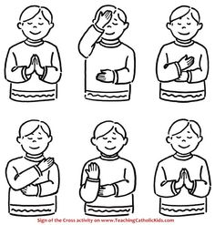

Guardian Angel Prayer:
Angel of God, my guardian dear, to whom God's love commits me here ever this day be at my side, to light and guard, to rule and guide.
Amen.

Glory Be:
Glory be to the Father and to the Son and to the Holy Spirit, as it was in the beginning is now, and ever shall be world without end.
Amen.
Morning Prayer:
O my God, I offer you this day, all I do and think and say. In union with what was done, on earth by Jesus Christ, your Son.
Amen.

Evening Prayer:
God, our Father, this day is done. We ask you and Jesus Christ, your Son, that with the Spirit, our welcome guest, you guard our sleep and bless our rest.
Amen.

