SCIENCES 4TH – 8TH GRADES

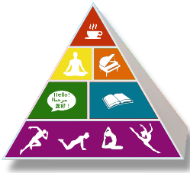

4th - 5th Grades will learn about the physical and chemical properties of matter.

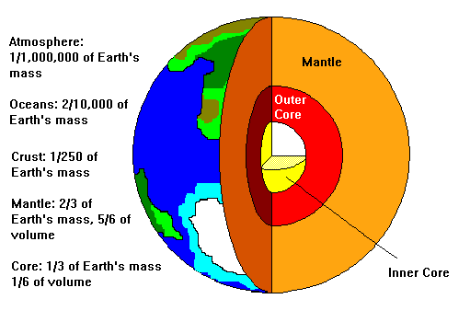
6th Grade will learn about the EARTH SYSTEMS and its place in the universe.
In EARTH SYSTEM, they will also learn about the forces and the energy that connects
us to EARTH.
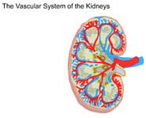

7th GRADE – LIFE SCIENCE- The students will learn about the processes of LIFE and the basics of the CELL-
ANIMAL AND PLANT.

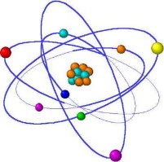

8th Grade – PHYSICAL SCIENCE -MATTER-ATOMS-STATES OF MATTER.

