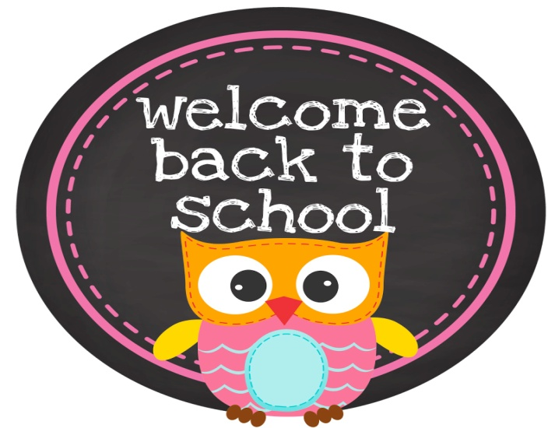
WELCOME TO MRS.VELAZCO'S PREK-4 CLASS!
Dear Parents,
Hello! My name is Gema Velazco and this is my third year teaching PreK-4 at Holy Ghost Catholic School. My prior experience before, I had the privilege of working with PreK 3-5 at a Head Start location for 6 years.
I would like to take this opportunity to welcome you and your child to a new year at Holy Ghost Catholic School. I am looking forward to getting to know you and your child throughout the year, which surely promises to bring us many new experiences and challenges. In order to make the year a successful one, teamwork and cooperation will be required by all. As your son or daughter's teacher, it is my goal to help him/her become a confident learner and I will do my best to help make this year a positive experience for your child.
I look forward to working in partnership with you throughout the year. I am confident that together we can provide the support and encouragement needed to help your child excel.

Children Need
- A small blanket for naptime.
- Change of clothes to keep in class.
- A sweater in case they get cold in class.
- Full-sized backpack (big enough for a 2-pocket folder)

Attendance
- Please help your child arrive to school on time.
- Arrive between 7:30 am-8:00am.
- After 8:00am the child would be mark as tardy.

Behavior Management

- Mrs.Velazco has behavior management system that is use every day. The behavior management system consists of earning a star, brain and heart. All three should be earn during the day to be able to go to the treasure box at the end of the day.
- The child earns their stay by following directions in class, lunch time and in mass.
- The child earns their brain by doing their work in class, and during learning centers.
- The child earns the heart by being nice to their classmates, using nice words and being respectful in mass.

Communication/Homework Red Folder

The red folder will be your child's to keep throughout the year. Please ensure that your child takes care of the folder and keeps it in good condition, as it will need to last all year long.

This folder will be your way of keeping in touch with your child's classroom activities each day. I will have important information from school/classroom; your child's weekly classroom newsletter homework, graded papers, and projects doing in class and conduct sheet that should be sign by parent daily.

This folder Must go home each night and return to school each morning. Please discuss the importance of making sure your child does this each night and remind them that it is their responsibility to take care of it.

Thank you,

Mrs.Velazco

